Information on tourist spots around Ojiya

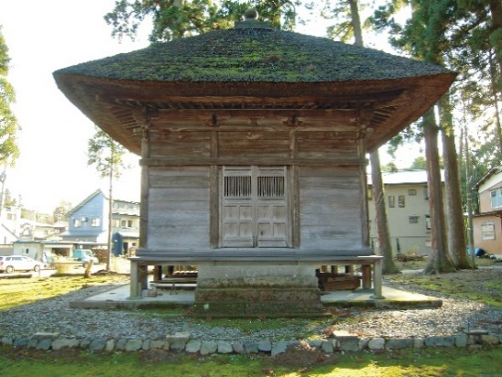
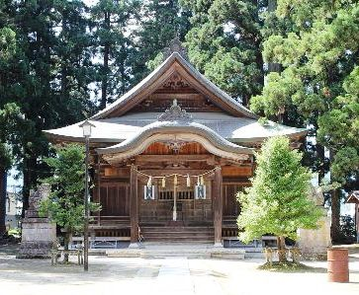

Uonuma-Shrine Amida-dō

- Uonuma-shrine
Uonuma-shrine has a long history. It is told that it was built in 97-30 BC. In the period of warring states, it was named “Kamiiyahiko-shrine” since it had the same enshrined deities as Iyahiko-shrine in Yahiko village. Local people called it “the second shrine” and it was popularly worshiped at this area. Then in 1780, it was named “Uonuma-shrine”.
The shrine enshrines Ame-no-kaguyama-no-mikoto and Toyotamahime-no-mikoto.
Its architectural style is the most common style of Shinto shrine called “Nagare-zukuri” characterized by very asymmetric gabled roof which front side has long extended roof.
- Amida-dō
Amida-dō is a small hall placed in the precinct. It was designated as a national important cultural property in 1563. Inside the hall, statues of Amida Nyorai(Amitabha Tathagata) and Dainichi Nyorai( Mahāvairocana) are enshrined and it is told that they are made of iron sand from Shinano river.
Episodes
- When Kenshin Uesugi prayed for a victory of the conquest of Kanto at Uonuma shrine, he saw a vision of Ame-no-kaguyama-no-mikoto and other deities from 18 subsidiary shrines going toward the same way he was going. He and his army were convinced of their victory and confidently headed to kanto. As he expected, he won the conquest and later donated land to the 18 shrines.
- During the World War Ⅱ, an exhausted sergeant who was fighting in China accidently fell in a well. He was a complete loss not knowing what to do. Suddenly an old man came out of nowhere and helped him with a rope. The man took him to his military unit and he just disappeared. On a lantern the man had, there was a word printed, “Kamiiyahiko Shrine”.

Address: 699-1, 2chō-me tsuchikawa, Ojiya

